**COMPARATOR**

**COMPARATOR**: A magnitude digital comparator is a combinational circuit that compares two digital or binary numbers in order to find out whether one binary number is equal, less than or greater than the other binary number. We logically design a circuit for which we will have two inputs one for A and other for B and have three output terminals, one for A > B condition, one for A = B condition and one for A < B condition.

Comparators are used in several different electronic circuits like analog to digital converters, voltage level detectors, zero-crossing detectors, etc. The most basic example of a comparator is an XNOR gate which produces a high or logic 1 output only when both its inputs are equal.

The block diagram of a typical comparator is shown in the following figure −

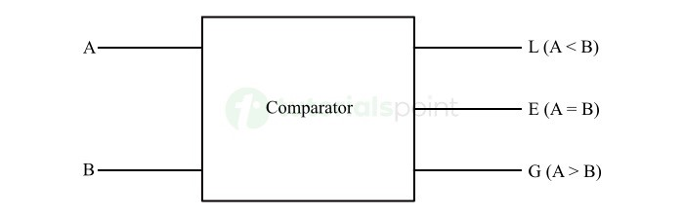

Here, A and B are the input bits, and L, E, and G are the output lines, where L indicates which number is smaller, E indicates equality, and G indicates the greater number.

**1 - BIT COMPARATOR**

A 1-bit magnitude comparator is a logic circuit which can compare two binary numbers of one bit each. It produces an output that indicates the relationship between the two input numbers.

In other words, a 1-bit magnitude comparator is one that compares two 1-bit binary numbers and generates an output showing whether one number is equal to or greater than or less than the other.

The block diagram of a 1-bit magnitude comparator is shown in the following figure −

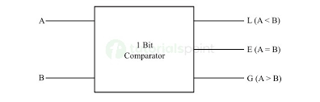

Here, A and B are the 1-bit input numbers, and L, E, and G are the output lines indicating less than or equal to or greater than relationship between A and B respectively.

The truth table for a 1-bit comparator is given below:

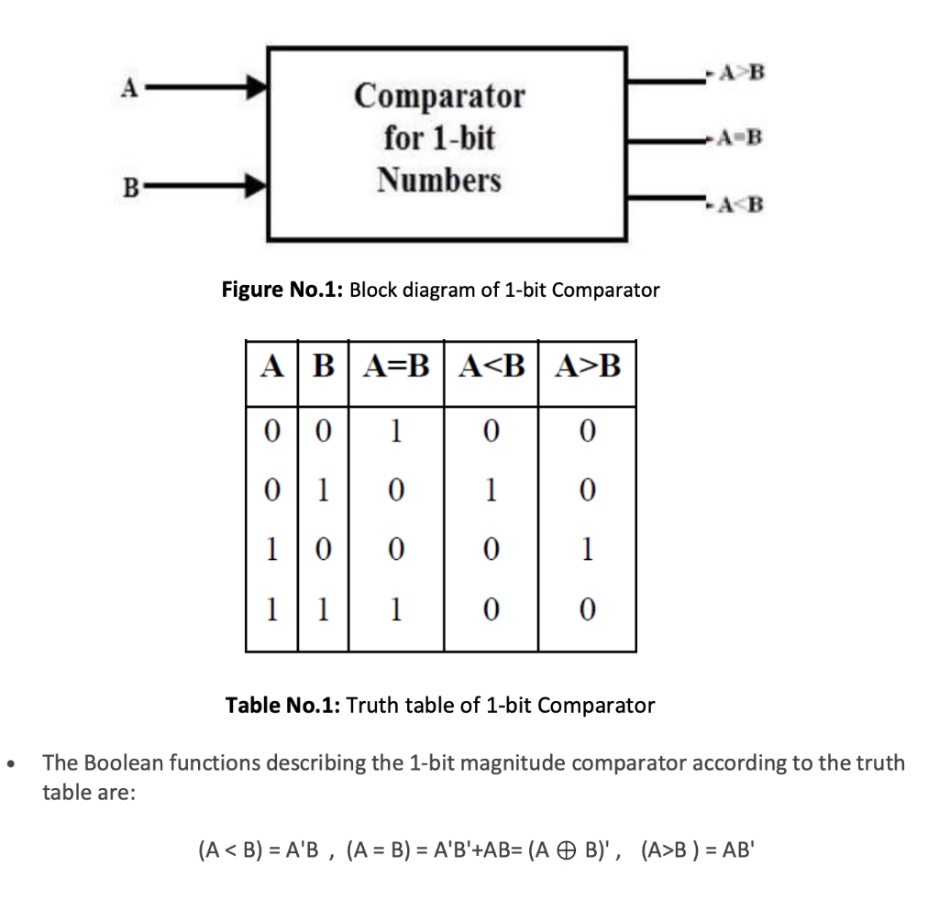

The logic expressions for G, L, E are obtained from the truth table

1. If A = 1 and B = 0, then A>B, therefore  
    A>B: G = AB`
2. If A = 0 and B = 1, then A<B, therefore

A<B: L = A`B

1. If A and B coincide i.e., A=B=0 or A=B=1, therefore

A=b: E = A xnor B

The logic circuit diagram of the 1-bit magnitude comparator is shown in the following figure.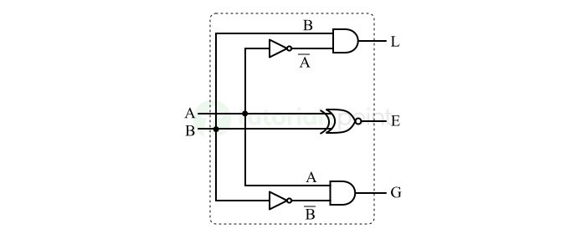

**2 – BIT COMPARATOR**

A digital combinational circuit used to compare the magnitudes of two 2-bit binary numbers and determine the relationship between them is called a 2-bit magnitude comparator.

Hence, the 2-bit magnitude comparator compares the values represented by two 2-bit binary numbers and then generates an output that indicates whether one number is equal to or greater than or less than the other.

The block diagram of a typical 2-bit magnitude comparator is shown in the following figure −

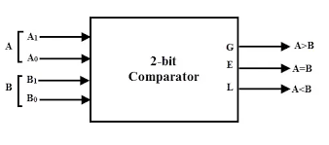

Here, the lines A0A1 and B0B1 represents two 2-bit binary number inputs and the lines L, E, and G represents the less than, equal to, and greater than output lines.

We can understand the operation of the 2-bit magnitude comparator with the help of its truth table given below −

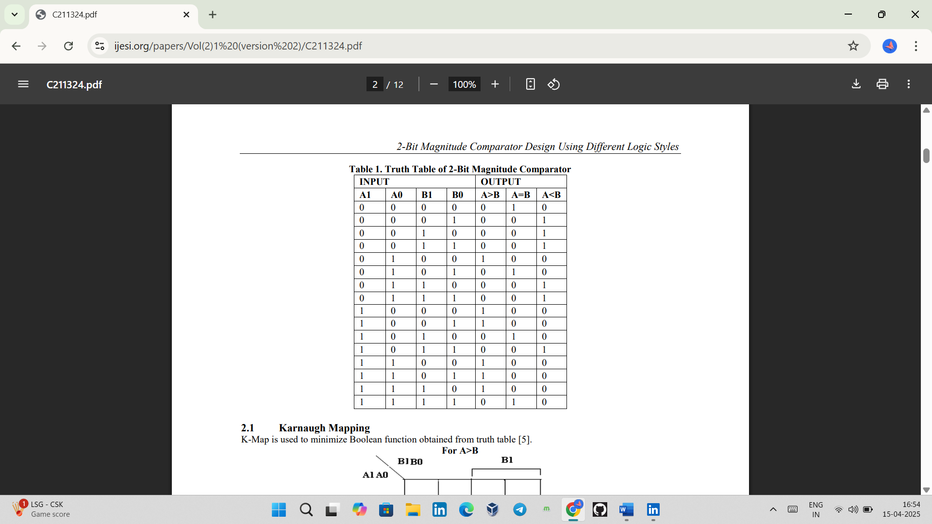

The logic for a 2-bit magnitude comparator, let the two 2-bit numbers be A = A1 A0 and B = B1 B0.

1. 1. If A1 = 1 and B1 = 0, then A>B, or

2. If A1 and B1 coincide and A0 = 1 and B0 = 0, then A>B. So, the logic expression for A>B is

A>B: G = A1 B1` + (A1 xnor B1) A0 B0`

1. 1. If A1 = 0 and B1 = 1, then A<B, or

2. If A1 and B1 coincide and A0 = 0 and B0 = 1, then A<B. So, the logic expression for A<B is

A<B: L = A1` B1 + (A1 xnor B1) A0` B0

1. If both A1, B1 and A0, B0 coincides the A = B. So, the logic expression for A=B is

A=B: E = (A1 xnor B1)( A0 xnor B0)

2-bit comparator circuit

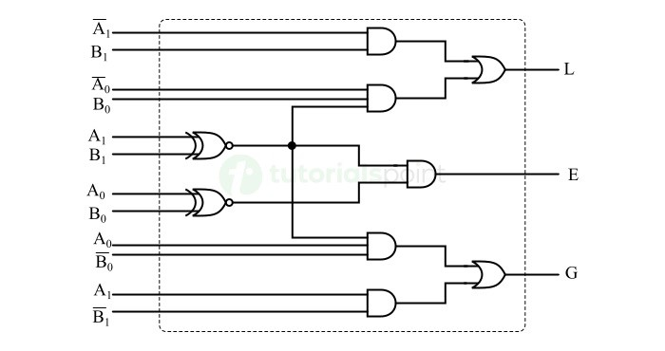

**4 – BIT COMPARATOR**

The 4-bit magnitude comparator is used in more complex digital circuits like microprocessors, microcontrollers, and many more.

It is a type of comparator that can compare the values or magnitudes of two 4-bit binary numbers and produce an output indicating whether one number is equal to or less than or greater than the other.

The block diagram of the 4-bit magnitude comparator is shown in the following figure –

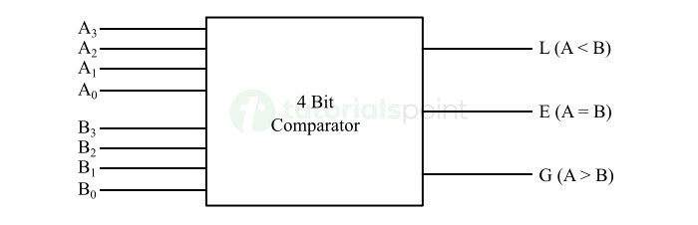

Here, the lines A3A2A0A1 and B3B2B0B1 represents two 4-bit binary number inputs and the lines L, E, and G represents the less than, equal to, and greater than output lines.

We can understand the operation of the 4-bit magnitude comparator with the help of its truth table given below –

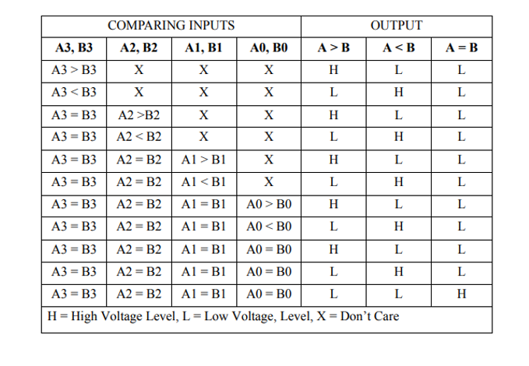

The logic for a 2-bit magnitude comparator, let the two 2-bit numbers be A = A3A2A0Aand B = B3B2B0B1.

1. 1. If A3 = 1 and B3 = 0, then A>B, or

2. If A3 and B3 coincide and if A2 = 1 and B2 = 0, then A>B, or

3. If A3 and B3 coincide, and A2 and B2 coincide, and if A1 = 1 and B1 = 0, then A>B, or

4. If A3 and B3 coincide, and A2 and B2 coincide, and A1 and B1 coincide, and if A0 = 1 and B0 = 0, then A>B.

From the above statements, we can get the logic expression for A>B and can be written as

A>B: G = A3 B3` +(A3 xnor B3) A2 B2` + (A3 xnor B3) (A2 xnor B2) A1 B1` + (A3 xnor B3) (A2 xnor B2) (A1 xnor B1)A0 B0`

1. 1. If A3 = 0 and B3 = 1, then A<B, or

2. If A3 and B3 coincide and if A2 = 0 and B2 = 1, then A<B, or

3. If A3 and B3 coincide, and A2 and B2 coincide, and if A1 = 0 and B1 = 1, then A<B, or

4. If A3 and B3 coincide, and A2 and B2 coincide, and A1 and B1 coincide, and if A0 = 0 and B0 = 1, then A<B.

From the above statements, we can get the logic expression for A<B and can be written as

A>B: L = A3` B3 +(A3 xnor B3) A2` B2 + (A3 xnor B3) (A2 xnor B2) A1` B1 + (A3 xnor B3) (A2 xnor B2) (A1 xnor B1)A0` B0

1. The comparator will produce an output A = B which is E, if all the corresponding bits in the two numbers are equal i.e., A3 = B3 and A2 = B2 and A1 = B1 and A0 = B0.

A=B: E = (A3 xnor B3)( A2 xnor B2) (A1 xnor B1)( A0 xnor B0)

The logic circuit implementation of the 4-bit magnitude comparator is shown in the following figure −

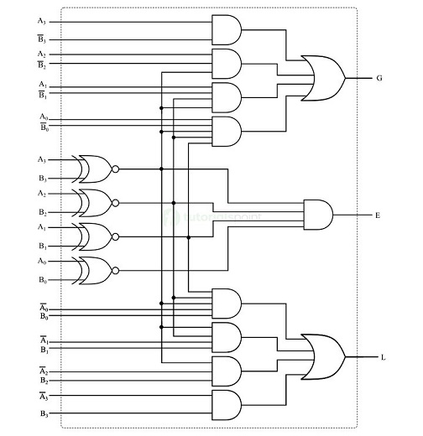

Applications of Comparator

1. Digital data processing
2. Memory management
3. ALUs
4. ADCs
5. Voltage Sensing and Threshold Triggering
6. Circuit control and switching
7. PWM Generation